UNIVERSITY OF GHANA
DEPARTMENT OF STATISTICS
ASTA 607
LECTURER: Prof.Minkah
22424333

a. The result of the help on the crabs data and code is show below

?crabs

The crabs data frame has 200 rows and 8 columns, describing 5 morphological measurements on 50 crabs each of two colour forms and both sexes, of the species Leptograpsus variegatus collected at Fremantle, W. Australia.
b. Question 1
b. To work with the data set, we install the mass package and load the data using the code below.
library(MASS)
library(e1071)
str(crabs)

data.frame': 200 obs. of 8 variables:
$ sp : Factor w/ 2 levels "B","O": 1 1 1 1 1 1 1 1 1 1 ...
$ sex : Factor w/ 2 levels "F","M": 2 2 2 2 2 2 2 2 2 2 ...
$ index: int 1 2 3 4 5 6 7 8 9 10 ...
$ FL : num 8.1 8.8 9.2 9.6 9.8 10.8 11.1 11.6 11.8 11.8 ...
$ RW : num 6.7 7.7 7.8 7.9 8 9 9.9 9.1 9.6 10.5 ...
$ CL : num 16.1 18.1 19 20.1 20.3 23 23.8 24.5 24.2 25.2 ...
$ CW : num 19 20.8 22.4 23.1 23 26.5 27.1 28.4 27.8 29.3 ...
$ BD : num 7 7.4 7.7 8.2 8.2 9.8 9.8 10.4 9.7 10.3 ...

c. the code and result for the frequency of species and sex is show below
reqTable <- table(crabs$sp,crabs$sex)
freqTable
pander(freqTable)

------------------
&nbsp; F M
-------- ---- ----
**B** 50 50

**O** 50 50
------------------

d.

par(mar=c(4,4,2,1))
barplot(freqTable,main = "Group Composition of Crabs Dataset",
ylab = "Frequency",col = rainbow(4),beside = TRUE)

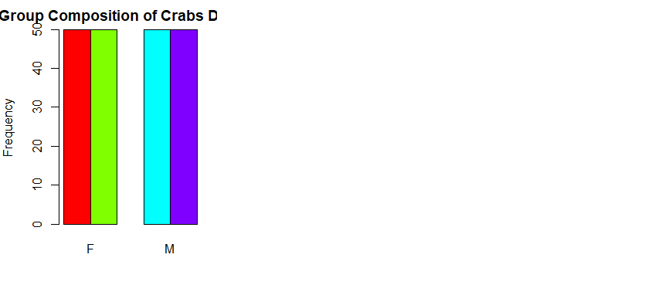

e. The data set is balanced across all the groups since all the groups have the same frequency of 50.
This will serve as a good ground for ANOVA since the problem of unequal sample size is taken care of

QUESTION TWO
groupbarBD <- boxplot(crabs$BD~crabs$sp+crabs$sex,
main = "Boxplot of Body Depth by Species and Sex"
,ylab = "Body Depth",xlab = "Species and sex",col = rainbow(4))

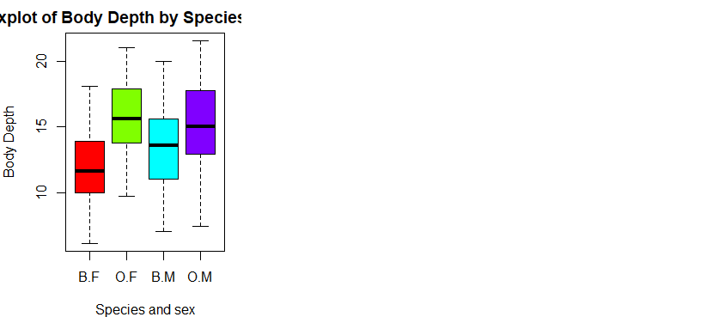
b. The distribution of the Body Dept, as shown by the grouped box plot below, has the last box, which is males that belong to species O in the boxplot plot has a longer whisker, indicating a higher variability in its observations. It can be seen that the second plot which is females that belong to species O has the largest median and the first one which is females in the species B has the lowest median

Question 3

a.
histogramB <- hist(crabs$CL[crabs$sp=="B"],main = "Histogram of Carapace Length for Species B",
xlab = "Carapace Length",col = "blue",breaks = "Sturges")

histogramO <- hist(crabs$CL[crabs$sp=="O"],main = "Histogram of Carapace Length for Species O",
xlab = "Carapace Length",col = "red",breaks = "Sturges")

b. 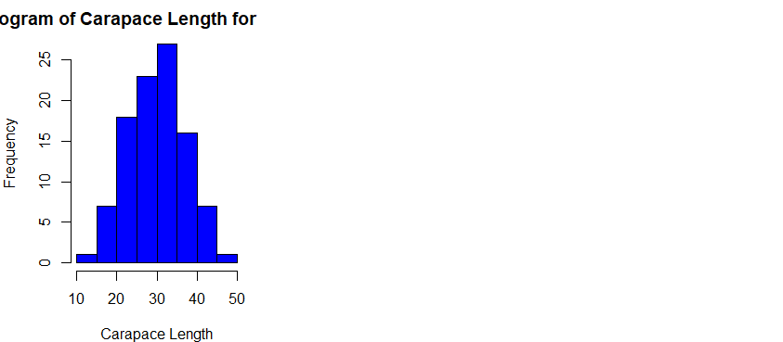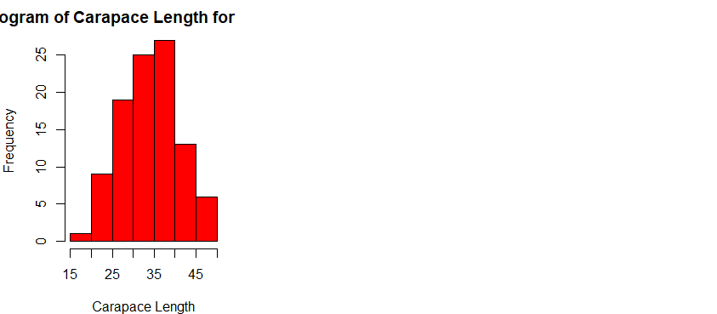

From the diagrams above, it can be seen that the distribution of the species O is slightly positively skewed, and the distribution of the species B is slightly negatively skewed.

Question 4
- meanFL <- tapply(crabs$FL, list(crabs$sp, crabs$sex), mean)
- meanFL
- meanRW <- tapply(crabs$RW, list(crabs$sp, crabs$sex), mean)
- meanRW
- meanCL <- tapply(crabs$CL, list(crabs$sp, crabs$sex ), mean)
- meanCL
- meanCL <- tapply(crabs$CL, list(crabs$sp, crabs$sex), mean)
- meanCL
- meanCW <- tapply(crabs$CW, list(crabs$sp, crabs$sex), mean)
- meanCW

- meanBD <- tapply(crabs$BD, list(crabs$sp, crabs$sex), me

The mean is displayed below
-----------------------
&nbsp; F M
-------- ------- -------
**B** 13.27 14.84

**O** 17.59 16.63

**B** 12.14 11.72

**O** 14.84 12.26

**B** 28.1 32.01

**O** 34.62 33.69

**B** 32.62 36.81

**O** 39.04 37.19

**B** 11.82 13.35

**O** 15.63 15.32
b.
gropedmeanbarplot <- barplot(meanData, main = "Mean Morphological Measurements by Species",
ylab = "Mean Value", col = rainbow(5),
beside = TRUE)

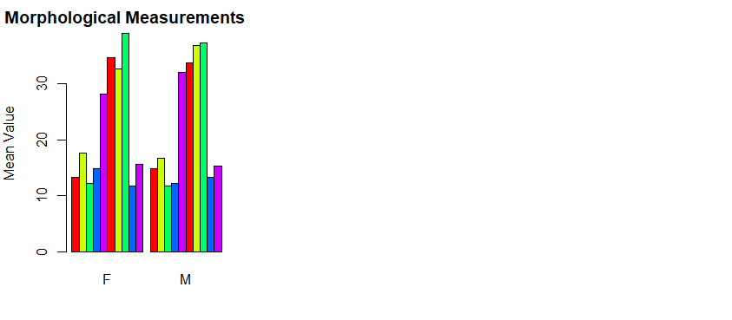

C. f females who belong to the species O have the greatest mean of 39.04 and males belonging to species B have the smallest mean of 11.72

c.

question 5
pairs(crabs[, 4:8], main =
"", pch = 19, col = rainbow(4)[as.numeric(crabs$sp)])

Output of pair plot
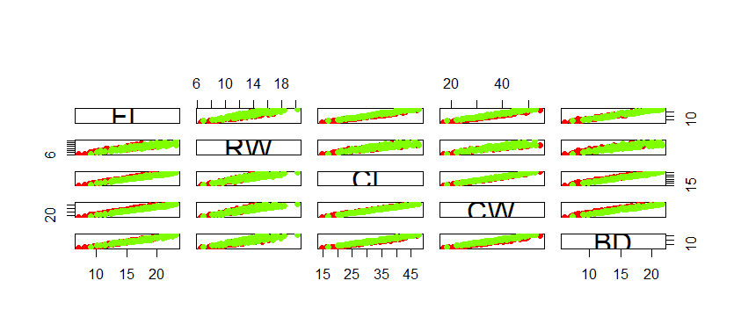

B.
From the Scatter plot above, it can be seen that all the variable are are highly positively correlated.
This means as one increase the other also increases in the same direction. This doesn’t mean causation.
QUESTION 6
From the crabs data set given, I loaded the data into R, The data set contains 200 variables, with 8 variables in total. The frequency table of species and sex shows that each of the species O and species B has equal number of observations which will prevent the problem of unequal variance for ANOVA aand other tests. It was confirm by the bar plot displayed below


The distribution of the Body Dept, as shown by the grouped box plot below, has the last box, which is males that belong to species O in the boxplot plot has a longer whisker, indicating a higher variability in its observations. It can be seen that the second plot which is females that belong to species O has the largest median and the first one which is females in the species B has the lowest median


The histogram showing the carapace length shows that the distribution of the species O is slightly positively skewed, and the distribution of the species B is slightly negatively skewed.
The group comparison of the mean measurement shows that f females who belong to the species O have the greatest mean of 39.04 and males belonging to species B have the smallest mean of 11.72\
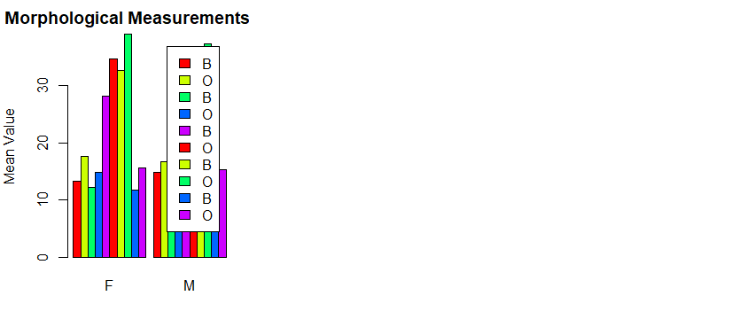

The relationship between measurements shows that all the pairs have a very strong positive correlation between the pairs.

